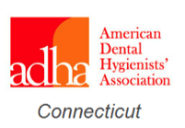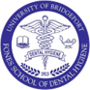
President-Elect Maria Cholewinski RDH, M.Ed invites you to;
A PROFESSIONAL DEVELOPMENT WORKSHOP
Dental Hygiene to Dental Therapy
Discussion regarding legislation in CT
By:
Dr. Jennifer Boyce & Susan Miklos EFDA,RDH, BDH,MSDH and Marion Manski, RDH, MS

Sunday, March 1, 2020 1-4pm-2CE’s
Health Science Center Room 404
Fones School of Dental Hygiene
60 Lafayette Street Bridgeport, CT
$25.00 members, $35.00 nonmembers, $15.00 students

Please RSVP by Feb 28th
Save the Date!
Strategic Planning Workshop!
Sunday April 26th
Place and Time TBA

